Eagle
Project

Bike Drive

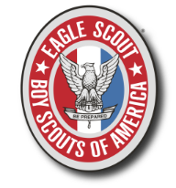
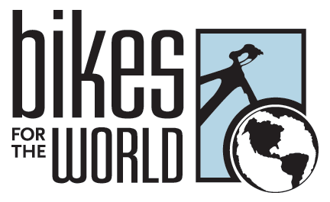

Have Used Bikes? Donate to the Boy Scouts of America.

Quinton Kohler is collecting bikes for an Eagle Scout Project. We ask you to donate your unused bikes, which will be given to those in need.

The drive will be held at Navy Elementary School on Saturday, June 8th, from 11 A.M. to 3 P.M.
We collect any type of bicycle, even if they are missing a few parts.

Out of town? No Problem! You can contact me by email, and we can pick up directly from your house.
All bikes are sent to impoverished in third world nations by Bikes for the World.
Bikes for the World requests a non-mandatory $10 donation to handle shipping costs. If possible, please bring money with the donation of any bike.

Questions? Need pickup?
Contact me: Quintonek@aol.com

